Divergence on sensor choices.

Sensor plays an important role in our robotics design to detect the exact location of the charging port. Sensors could include IR, ultrasonic sensors, colour sensors, camera. One important idea is design for assembly

Pugh Chart for each sensor

IR Sensor and Ultrasonic

pros:

* Relatively cheap
* Easy to use

cons:

* IR sensor Depends on colour
* Not good with distances too far or too close

Colour Sensor:

pros:

* Relatively cheap
* Can easily detect colour
* Easy to use

cons:

* Must be close to the surface to detect colour
* Cannot measure distance

Camera:

pros:

* Can take image for later processing
* We can make use of existing libraries

cons:

* A camera can be expensive
* Computer vision is less familiar
* Can be hard to implement

|  |  |  |  |  |
| --- | --- | --- | --- | --- |
| Metric | IR Sensor | Ultrasonic Sensor | Colour Sensor | Camera |
| Cost | + | + | + | Reference |
| Distance Detection | + | + | - | Reference |
| Angle Detection | - | - | -- | Reference |

Computer vision algorithm.

1. One camera and one sensor
2. Two cameras

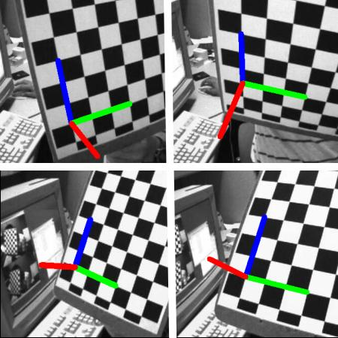

It mainly makes use of the pose estimation of a well known image like the chessboard.

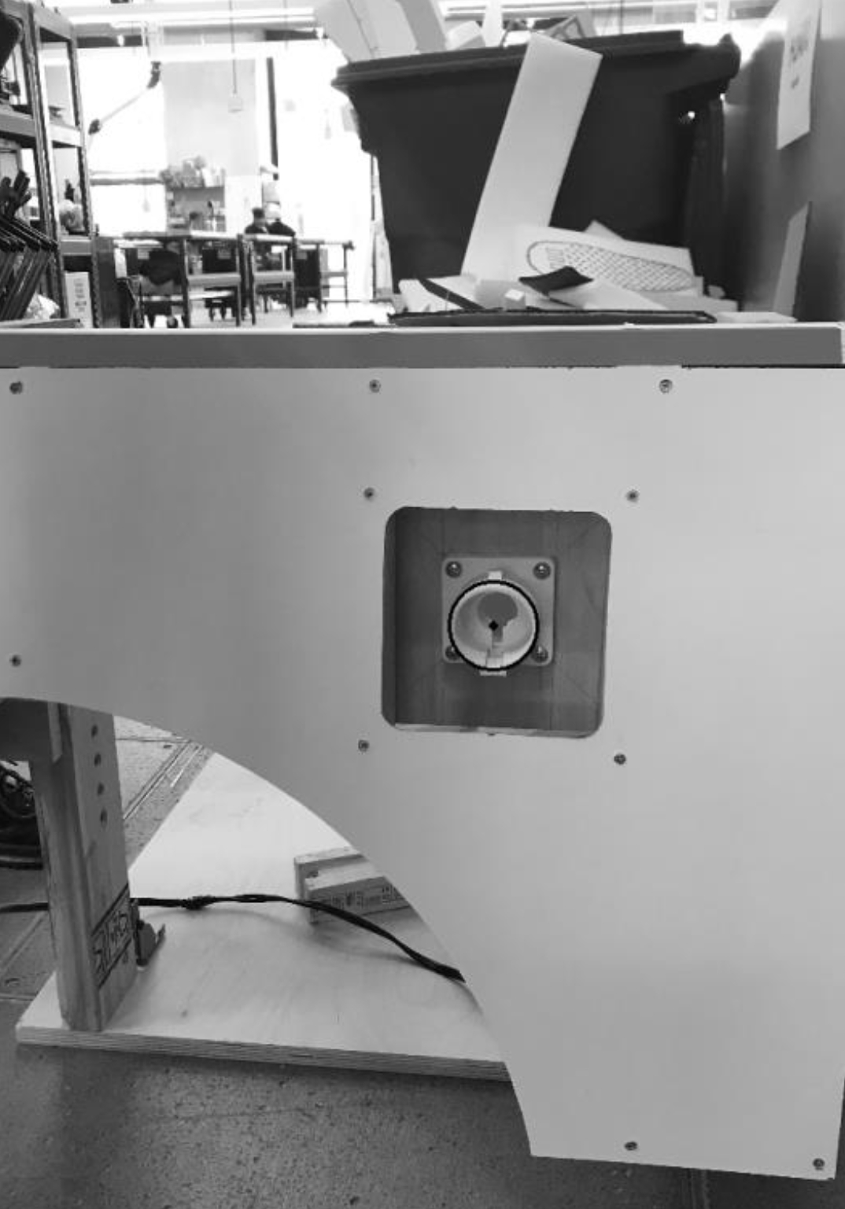

Camera:

|  |  |  |  |  |
| --- | --- | --- | --- | --- |
| Metric | Playstation Eye | Camera Module for Raspberry Pi | Logitech C905 | Microsoft LifeCam HD-5000 |
| Cost | - | + | - | Reference |
| Resolution | -- | same | same | Reference |

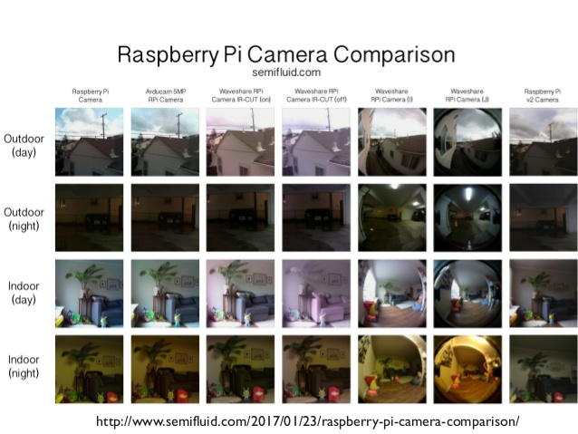

Microsoft LifeCam HD-5000

pros:

* I have owned it for 8 years so its value has depreciated.
* We can start testing with it right away

Camera Module for Raspberry Pi

pros:

* Cheap
* Decent resolutoin

cons:

* Limited to Raspberry Pi

Playstation Eye

pros:

* It’s good for people that already have them

cons:

* low resolution